Filing pursuant to Rule 425 under the

Securities Act of 1933, as amended

Filer: International Flavors & Fragrances Inc.

Subject Companies: International Flavors & Fragrances Inc.; Frutarom Industries Ltd.

Filer’s Commission File Number: 1-4858

Date: May 7, 2018

TRANSCRIPT – MERGER VIDEO

(RT: 6:00)
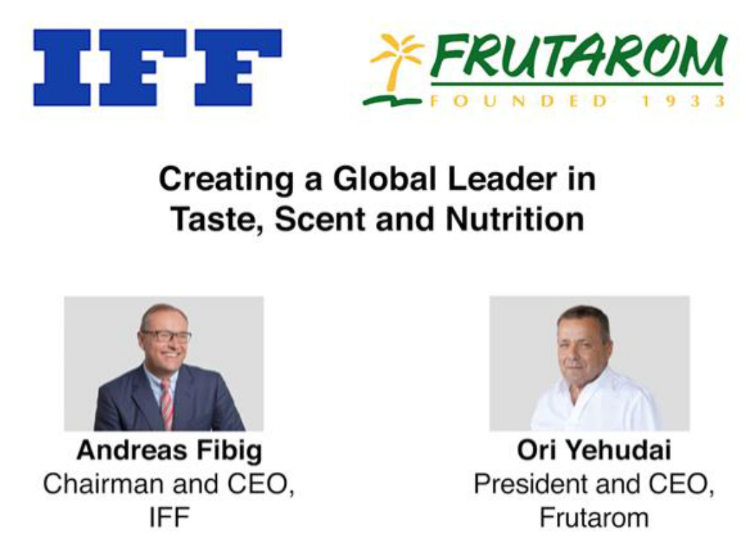

Graphic Question: “What did you announce today?”

Andreas Fibig, Chairman & CEO, IFF: I’m very excited because we are combining Frutarom and IFF. Two companies with a great tradition and which will make us a leader in taste, scent and nutrition. Ori, what do you think?

Ori Yehudai, President & CEO, Frutarom: I absolutely agree and for Frutarom it’s an additional – very, very positive milestone in our journey. We started long long ago. I joined Frutarom like 33—years ago. And for me, it’s another very very important mile forward. In a very positive things to create really the success of Frutarom, the success of IFF – the combination between them, how to make really one plus one equal four. That, that, this was our vision, this is what we were able to achieve, and that’s what we will achieve together Andreas.

Andreas Fibig: And we have a real opportunity to create a global leader in our, in our space with fast growth. And I’m really confident that this will happen in the next months to come.

Graphic Question: “What is most exciting about this combination?”

Ori Yehudai: Look, the truth is that neither Dr. John Farber, our Chairman, nor me really considered selling the business. But, when we got an approach from Andreas and we thought about IFF, we thought there couldn’t be a better choice than IFF to really become the global leader. And I think that’s the step that we are taking now will really bring us there quickly and efficiently and I’m very excited and happy about it.

Andreas Fibig: Well, my point of view, first of all, Ori, I would like to complement the Frutarom team for what you have achieved in the last couple of years —which is really amazing. And I agree with Ori in a sense, the complementarity of the businesses is so great for the two of us that this is probably the ideal combination you can think of —in terms of geographies, in terms of our portfolio which is very complementary and also the customer base. So, I think this makes just a lot of good sense.

Ori Yehudai: Part of our consideration was that if there is a partner that really is complementary to us, and is not really competing with Frutarom, but we can add product, technology, customers and many other things. That’s the right thing that we can do for our employees – for all stakeholders.

Andreas Fibig: I agree. I think that’s what it is.

Graphic Question: “What does this transaction mean for employees of IFF and Frutarom?”

Andreas Fibig: First of all, I believe everybody has to understand that this bringing together of these two great teams and organizations is all about growth. It’s not just that it makes us a global leader, but we want to expand on this going forward. So, I deep heartedly believe this will create a lot of opportunities for many of the people in our company for their own career and development advancement.

Ori Yehudai: I fully agree, Andreas, and as you know, maybe you don’t know, but for me it was the most important thing. I mean, the way I think about all those employees that contribute to the success of Frutarom, and to where we are now, and we are just now entering to additional very, very good, positive period, where we really leverage on the capabilities of the two companies—on synergies, on cross selling, and how really making one plus one equal four. So, it’s all about growth and the employees will continue to be part of that growth.

Graphic Question: “What can employees expect in terms of next steps?”

Ori Yehudai: What we are, Frutarom is growing fast and in most cases faster than the markets where we operate. I truly believe that this will continue and this is only about you. You will make it happen, our company will continue to grow, in the same time we’ll create the teams that will ensure excellent integration and really combining the things in the best way, for the benefit of our customers, our employees and all stakeholders.

Andreas Fibig: Be reassured that we will update you on a regular basis so you will always know what’s going on. But what I expect from the teams—from the Frutarom and the IFF team right now, it’s business as usual, making sure we succeed in the marketplace, and we make sure that we do an excellent integration of the two teams, and we’ll be ready for day one.

Graphic Question: “Do you have a favorite flavor or fragrance from your combined portfolio of products?”

Andreas Fibig: We are very aligned on this one – it will be espresso flavor, because we need a lot of espresso to get through the next couple of weeks, because we want to reach out to all the teams and we want to make sure we do an excellent preparation for day one.

Ori Yehudai: I fully agree and let’s add to that a glass of wine.

Andreas Fibig: Absolutely. (Laughs)

Cautionary Statement Regarding Forward Looking Statements

This press release contains forward-looking statements within the meaning of Section 27A of the Securities Act of 1933, as amended, and Section 21E of the Securities Exchange Act of 1934, as amended. All statements regarding IFF’s or Frutarom’s expected future financial position, results of operations, cash flows, financing plans, business strategy, budgets, capital expenditures, competitive positions, growth opportunities, plans and objectives of management and statements containing the words such as “anticipate,” “approximate,” “believe,” “plan,” “estimate,” “expect,” “project,” “could,” “should,” “will,” “intend,” “may” and other similar expressions, are forward-looking statements. Statements in this communication concerning IFF’s or Frutarom’s business outlook or future economic performance, anticipated profitability, revenues, expenses or other financial items, and product or services line growth, together with other statements that are not historical facts, are forward-looking statements that are estimates reflecting management’s best judgment based upon currently available information. Such forward-looking statements are inherently uncertain, and stockholders and other potential investors must recognize that actual results may differ materially from expectations as a result of a variety of factors, including, without limitation, those discussed below. Such forward-looking statements are based upon management’s current expectations and include known and unknown risks, uncertainties and other factors, many of which IFF and Frutarom are unable to predict or control, that may cause IFF’s or Frutarom’s actual results, performance or plans to differ materially from any future results, performance or plans expressed or implied by such forward-looking statements. These statements involve risks, uncertainties and other factors discussed below and detailed from time to time in IFF’s filings with the Securities and Exchange Commission (the “SEC”) and Frutarom’s filings with the Israeli Securities Authority.

Risks and uncertainties related to IFF’s proposed acquisition of Frutarom include, but are not limited to, the inability to obtain required regulatory approvals for the acquisition, the timing of obtaining such approvals and the risk that such approvals may result in the imposition of conditions that could adversely affect the combined company or the expected benefits of the acquisition, the inability to obtain the requisite Frutarom shareholder approval of the transaction, the risk that a condition to closing of the acquisition may not be satisfied on a timely basis or at all, the failure of the proposed transaction to close for any other reason, uncertainties as to access to available financing (including financing for the acquisition or refinancing of IFF or Frutarom debt) on a timely basis and on reasonable terms, the impact of IFF’s proposed financing on its liquidity and flexibility to respond to other business opportunities, whether the acquisition will have the accretive effect on IFF’s earnings or cash flows that it expects, the inability to obtain, or delays in obtaining, cost savings and synergies from the acquisition, costs and difficulties related to the integration of Frutarom’s businesses and operations with IFF businesses and operations, unexpected costs, liabilities, charges or expenses resulting from the acquisition, adverse effects on IFF’s stock price resulting from the acquisition, the inability to retain key personnel, and potential adverse reactions, changes to business relationships or competitive responses resulting from the acquisition.

In addition to the factors set forth above, other factors that may affect IFF’s plans, results or stock price are set forth in IFF’s Annual Report on Form 10-K, Quarterly Reports on Form 10-Q and Current Reports on Form 8-K. Other factors that may affect Frutarom’s plans, results or stock price are set forth in Frutarom’s filings with the Israeli Securities Authority.

Many of these factors are beyond IFF’s and Frutarom’s control and IFF and Frutarom caution investors that any forward-looking statements made by IFF or Frutarom are not guarantees of future performance. IFF and Frutarom disclaim any obligation to update any such factors or to announce publicly the results of any revisions to any of the forward-looking statements to reflect future events or developments.

Important Additional Information and Where to Find It

This communication does not constitute an offer to sell or the solicitation of an offer to buy any securities or a solicitation of any vote or approval, nor shall there be any sale of securities in any jurisdiction in which such offer, solicitation or sale would be unlawful prior to registration or qualification under the securities laws of any such jurisdiction. IFF will file with the SEC a registration statement on Form S-4 that will include a proxy statement of Frutarom that also constitutes a prospectus of IFF. INVESTORS AND SECURITY HOLDERS OF FRUTAROM ARE URGED TO READ THE DEFINITIVE PROXY STATEMENT/PROSPECTUS AND OTHER DOCUMENTS THAT WILL BE FILED WITH THE SEC CAREFULLY AND IN THEIR ENTIRETY WHEN THEY BECOME AVAILABLE BECAUSE THEY WILL CONTAIN IMPORTANT INFORMATION. Investors and security holders will be able to obtain free copies of the registration statement (when available) and other documents filed with the SEC by the parties through the website maintained by the SEC at http://www.sec.gov. Copies of the documents filed with the SEC by IFF will be available free of charge on IFF’s internet website at ir.iff.com.

[END OF TRANSCRIPT]

