Filing pursuant to Rule 425 under the

Securities Act of 1933, as amended

Filer: International Flavors & Fragrances Inc.

Subject Companies: International Flavors & Fragrances Inc.; Frutarom Industries Ltd.

Filer’s Commission File Number: 1-4858

Date: May 11, 2018

The following communications were made available by posts on Facebook, the IFF Blog, LinkedIn and YouTube.

Facebook Post:

International Flavors & Fragrances agrees to acquire Frutarom to create a global leader in taste, scent and nutrition. The combination unites two industry-leading, innovative companies with complementary customers, capabilities and geographic reach, resulting in more exposure to fast growing end markets and an enhanced platform to deliver sustainable, profitable growth.

https://www.facebook.com/InternationalFlavorsandFragrances/photos/pcb.2009198642680243/2009197496013691/?type=3

IFF Blog Post:

A Look at the Combination of IFF and Frutarom

12:25 PM

It’s the start of exciting new chapter for us. The combination of IFF and Frutarom unites two industry-leading, innovative companies with complementary customers, capabilities and geographic reach. We look forward to welcoming Frutarom to the IFF family. In this infographic, you will find more details about our historic milestone and below, watch Andreas Fibig and Ori Yehudai announce the historic agreement.

http://blogs.iff.com/2018/05/a-look-at-combination-of-iff-and.html

LinkedIn Posts:

International Flavors & Fragrances agrees to acquire Frutarom to create a global leader in taste, scent and nutrition. The combination unites two industry-leading, innovative companies with complementary customers, capabilities and geographic reach, resulting in more exposure.

http://ir.iff.com/phoenix.zhtml?c=65743&p=irol-newsArticle&ID=2347222

It’s an exciting new chapter for us. Here’s a snapshot of the largest deal in our history: Frutarom to join the International Flavors & Fragrances family.

https://www.linkedin.com/company/iff/?

lipi=urn%3Ali%3Apage%3Ad_flagship3_company%3BBKIlplRpQeGHLezPXJj%2FOQ%3D%3D&licu=urn%3Ali%3Acontrol%3Ad_flagship3_company-object#

RT @fdiforum: IFF to create ‘taste, scent &amp: nutrition leader’ with $9bn Frutarom acquisition: International Flavors &amp: Fragrances (IFF) is a…
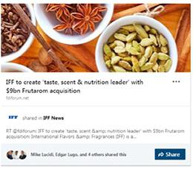

2

RT @WSJ:International Flavors &amp: Fragrances makes a $6 billion bet Israeli spice firm Frutarom to create one of the biggest players in the…
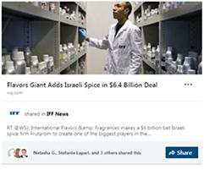

“The Frutarom deal is the biggest in IFF’s history and the biggest-ever in the industry.
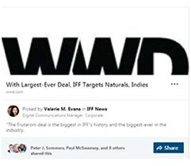

3

https://www.foodnavigator-usa.com/Article/2018/05/07/IFF-to-acquire-Frutarom-to-create-global-flavors-and-natural-ingredients-empire-in-7.1bn-deal#.WvHS9Wq88NQ.linkedin

RT @CNBC:IFF to buy Israel’s Frutarom for $7.1 bln, nearing top spot
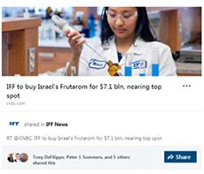

4

RT @i24NEWS_FR: L’entreprise israelienne #Frutarom rachetee pour 7 milliards de dollars
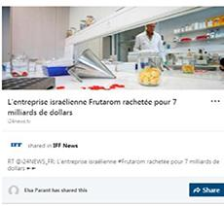

Founded in Haifa in 1933, Frutarom began by creating herbal and fruit essences using local produce, exporting nearly all of its stock. Employees would also spend….
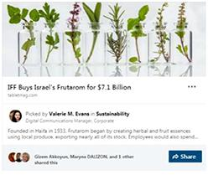

5

An exciting new chapter! Frutarom to join the International Flavors & Fragrances family!
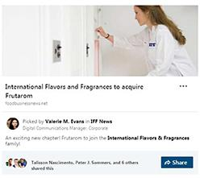

RT @PandFMagazine: Breaking #market news! @IFF is set to acquire Frutarom #marketMonday
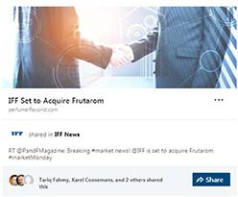

6

We look forward to welcoming Frutarom to the IFF family
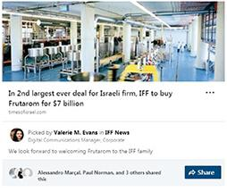

RT @HappiMagazine: Big raw materials news for the #personalcare and #householdcare marketplaces as @IFF acquires #Frutarom. …
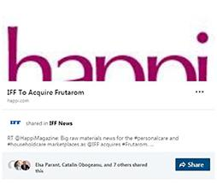

7

RT @BevNET: .@IFF Acquires Frutarom for $7.1B
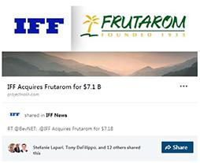
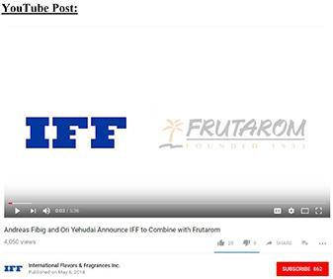

Cautionary Statement Regarding Forward Looking Statements

This communication contains forward-looking statements within the meaning of Section 27A of the Securities Act of 1933, as amended, and Section 21E of the Securities Exchange Act of 1934, as amended. All statements regarding IFF’s expected future financial position, results of operations, cash flows, financing plans, business strategy, budgets, capital expenditures,

8

competitive positions, growth opportunities, plans and objectives of management and statements containing the words such as “anticipate,” “approximate,” “believe,” “plan,” “estimate,” “expect,” “project,” “could,” “should,” “will,” “intend,” “may” and other similar expressions, are forward-looking statements. Statements in this communication concerning IFF’s business outlook or future economic performance, anticipated profitability, revenues, expenses or other financial items, and product or services line growth, together with other statements that are not historical facts, are forward-looking statements that are estimates reflecting the best judgment of IFF based upon currently available information. Such forward-looking statements are inherently uncertain, and stockholders and other potential investors must recognize that actual results may differ materially from IFF’s expectations as a result of a variety of factors, including, without limitation, those discussed below. Such forward-looking statements are based upon management’s current expectations and include known and unknown risks, uncertainties and other factors, many of which IFF is unable to predict or control, that may cause IFF’s actual results, performance or plans to differ materially from any future results, performance or plans expressed or implied by such forward-looking statements. These statements involve risks, uncertainties and other factors discussed below and detailed from time to time in IFF’s filings with the Securities and Exchange Commission (the “SEC”).

Risks and uncertainties related to IFF’s proposed acquisition of Frutarom include, but are not limited to, the inability to obtain required regulatory approvals for the acquisition, the timing of obtaining such approvals and the risk that such approvals may result in the imposition of conditions that could adversely affect the combined company or the expected benefits of the acquisition, the inability to obtain the requisite Frutarom shareholder approval of the transaction, the risk that a condition to closing of the acquisition may not be satisfied on a timely basis or at all, the failure of the proposed transaction to close for any other reason, uncertainties as to access to available financing (including financing for the acquisition or refinancing of IFF or Frutarom debt) on a timely basis and on reasonable terms, the impact of IFF’s proposed financing on its liquidity and flexibility to respond to other business opportunities, whether the acquisition will have the accretive effect on IFF’s earnings or cash flows that it expects, the inability to obtain, or delays in obtaining, cost savings and synergies from the acquisition, costs and difficulties related to the integration of Frutarom’s businesses and operations with IFF businesses and operations, unexpected costs, liabilities, charges or expenses resulting from the acquisition, adverse effects on IFF’s stock price resulting from the acquisition, the inability to retain key personnel, and potential adverse reactions, changes to business relationships or competitive responses resulting from the acquisition.

In addition to the factors set forth above, other factors that may affect IFF’s plans, results or stock price are set forth in IFF’s Annual Report on Form 10-K, Quarterly Reports on Form 10-Q and Current Reports on Form 8-K.

Many of these factors are beyond IFF’s control and IFF cautions investors that any forward-looking statements made by IFF are not guarantees of future performance. IFF disclaims any obligation to update any such factors or to announce publicly the results of any revisions to any of the forward-looking statements to reflect future events or developments.

Important Additional Information and Where to Find It

9

This communication does not constitute an offer to sell or the solicitation of an offer to buy any securities or a solicitation of any vote or approval, nor shall there be any sale of securities in any jurisdiction in which such offer, solicitation or sale would be unlawful prior to registration or qualification under the securities laws of any such jurisdiction. IFF will file with the SEC a registration statement on Form S-4 that will include a proxy statement of Frutarom that also constitutes a prospectus of IFF. INVESTORS AND SECURITY HOLDERS OF FRUTAROM ARE URGED TO READ THE DEFINITIVE PROXY STATEMENT/PROSPECTUS AND OTHER DOCUMENTS THAT WILL BE FILED WITH THE SEC CAREFULLY AND IN THEIR ENTIRETY WHEN THEY BECOME AVAILABLE BECAUSE THEY WILL CONTAIN IMPORTANT INFORMATION. Investors and security holders will be able to obtain free copies of the registration statement (when available) and other documents filed with the SEC by the parties through the website maintained by the SEC at http://www.sec.gov. Copies of the documents filed with the SEC by IFF will be available free of charge on IFF’s internet website at ir.iff.com.

10

